**DAILY ONLINE ACTIVITIES SUMMARY**

|  |  |  |  |  |  |  |  |
| --- | --- | --- | --- | --- | --- | --- | --- |
| **Date:** | **21/05/2020** | | | | **Name:** | **Deena Muthappa** | |
| **Sem & Sec** | **8th sem, A sec** | | | | **USN:** | **4AL16CS028** | |
| **Online Test Summary** | | | | | | | |
| **Subject** | | **SMS 2** | | | | | |
| **Max. Marks** | | **60** | | **Score** | | **60** | |
| **Certification Course Summary** | | | | | | | |
| **Course** | **Introduction to Ethical Hacking** | | | | | | |
| **Certificate Provider** | | | **Great Learning** | **Duration** | | | **254 mins** |
| **Coding Challenges** | | | | | | | |
| **Problem Statement:** 1 C Program to Reverse a Linked List in groups of given size  2 program in Python to find Area-Circle, Circumference-Circle, Area-Square, Circumference-Square using functions with menu    **Create seperate functions for each choice of menu** | | | | | | | |
| **Status: Completed** | | | | | | | |
| **Uploaded the report in Github** | | | | **Yes** | | | |
| **If yes Repository name** | | | | **deenamuthappa/Coding-Challeneges** | | | |
| **Uploaded the report in slack** | | | | **Yes** | | | |

Online Test Details:

Online examination is conducting a test online to measure the knowledge of the participants on a given topic. With online examination students can do the exam online. The test was on the subject System Modeling and Simulation under the topic Random variate generation technique.

Certification Course Details:

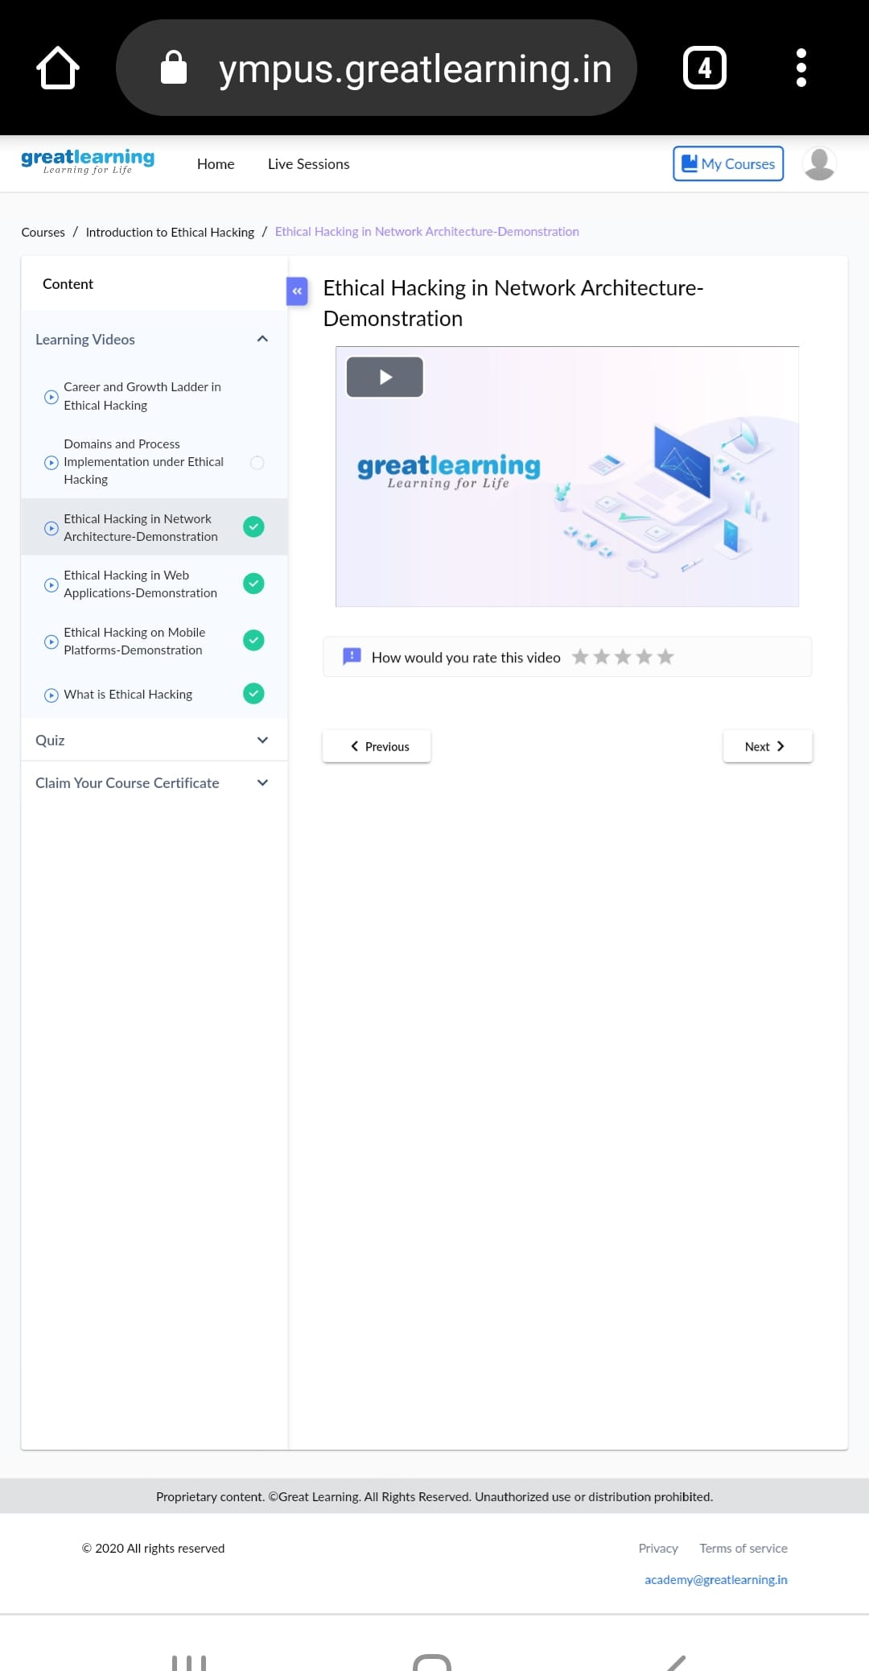

An ethical hacker, also referred to as a white hat hacker, is an information security expert who systematically attempts to penetrate a computer system, network, application or other computing resource on behalf of its owners and with their permission to find security vulnerabilities.

Coding Challenges Details:

**#include <stdlib.h>**

**struct node**

**{**

**int data;**

**struct node next;**

**};**

**struct Node reverse(struct Node head,int k)**

**{**

**struct Node current= head;**

**struct Node next= Null;**

**struct Node prev= Null;**

**int count = 0;**

**while(current!=Null && count<k)**

**{**

**next= current->next;**

**current->next = prev;**

**prev= current;**

**current= next;**

**count++;**

**}**

**if ( next!=Null)**

**head->next= reverse( next,k);**

**return prev;**

**}**

**void push( struct Node ==head_ref,int new_data)**

**{**

**struct Node= new_node= (struct Node) malloc(sizeof(struct Node));**

**}**

**}**

**int main()**

**{**

**Struct node *prev,*head,*p;**

**int n,i;**

**printf ("number of elements:");**

**scanf("%d",&n);**

**head=NULL;**

**for(i=0;i<n;i++)**

**{**

**p=malloc(sizeof(struct node));**

**scanf("%d",&p->data);**

**p->next=NULL;**

**if(head==NULL)**

**head=p;**

**else**

**prev->next=p;**

**prev=p;**

**}**

**return 0;**

**}**

**Program 2**

#main.py

def AreaCircle(r):

return rr

def CircumferenceCircle(r):

return 23.14*r

def AreaSquare(b,h):

return bh

def CircumferenceSquare(h):

return 4h

#pm.py

from main import*

r=float(input("Enter Radius Of Circle: "))

ac=AreaCircle(r)

print("Area Of Circle: ",ac)

cc=CircumferenceCircle(r)

print("Circumference Of Circle is: ",cc)

b=float(input('Enter Base Of Square: '))

h=float(input('Enter Height Of Square: '))

As=AreaSquare(b,h)

print("Area Of Square Is: ",As)

cs=CircumferenceSquare(h)

print("Circumference Of Square Is: ",cs)

program 3

Python program in number right angled triangle

Enter number 5

5 4 3 2 1

4 3 2 1

3 2 1

2 1

1

rows = int(input("enter number of rows "))

for i in range(0, rows + 1):

for j in range(rows - i, 0, -1):

print(j, end=' ')

print()